Gatewayand host tool User Guide

# Introduction

The gateway is separate to two parts: firmware and host software. The hardware interface is USB-UART. Telink provide the USB driver.

## Firmware

* EVK board x 1
* Coordinator binary file x 1

## Host

* zllHostTool x 1 (supplied source code and makefile)
* linux PC/BeagleBone/Windows with Cygwin

# Test Environment set up

* Step 1: Burn bin file to EVK board through wtcdb tool.
* Step 2: RePowerthe EVK and verify whether the USB-UART be recognized by OS. In windows we should install Telink provided driver, and in Linux, it could be automatically identify to ttyACM0. The path should be /dev/ttyACM0.
* Step 3: Open the UART tool with baudrate 115200 databit 8 stopbit 1 parity None.
* Step 4: Power up the telink provided Zlight board and press the button to make it join network. If join success, there should be some information displayed in the UART tool.
* Step 5: Send command through UART tool manually.

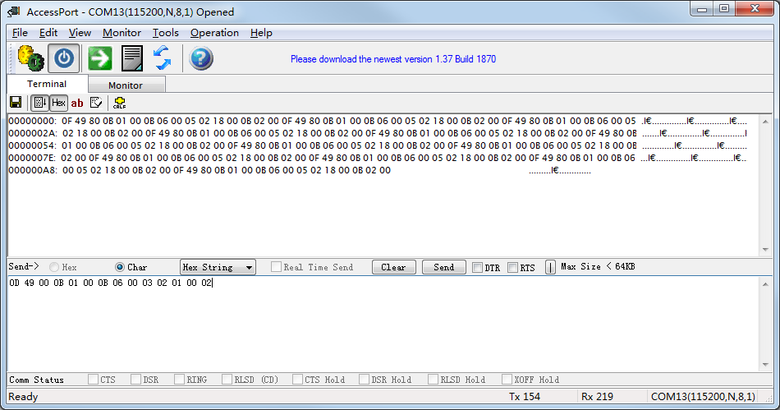

# Host ToolUsage

* Step 1: Get source code from SVN server
* Step 2: In command line, input “make”. zllHostTool (Linux) or zllHostTool.exe (Windows) will be generated.
* Step 3: Execute commad.

Eg: ./zllHostTool /dev/ttyACM0 (Linux)

zllHostTool.exe /dev/ttyS12 (cygwin)

* Step 4: Send host command. Example:

On: setstate –n0x0001 –e0x0b –m0x02 –v1

Off: setstate –n0x0001 –e0x0b –m0x02 –v0

Move to level: setlevel –n0x0001 –e0x0b –m0x02 –vf0 –t0x0a

Parameter Detail: Reference to <http://processors.wiki.ti.com/index.php/ZStack-Lighting-1.0.1_Host_Interface_C_Examples>

-n: network address

-e: end point

-m: address mode

-v: value

-t: transaction time

